# ITP 499, Fall 2021

# Homework 8 20 points

**Problem 1**

* Go to <https://developers.sap.com/tutorials/cai-bot-getting-started.html>

Then follow to the tutorial to build a chat-bot.

Insert screenshots to support each answer.

1. What is the chat bot capable of answering? (2)

It can perform actions like recognizing greeting, understanding when asked for a joke, providing a joke, and knowing the user’s reaction.

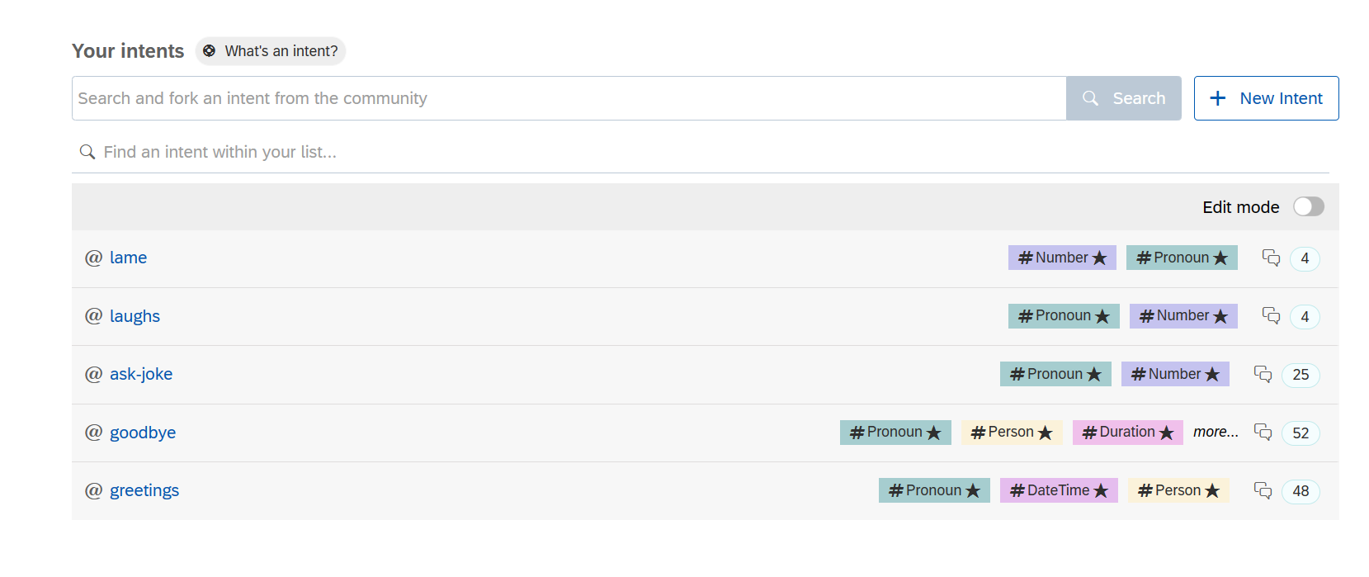

1. What skills does the chat bot have? (2)

Tell joke, greeting, disambiguation, fallback

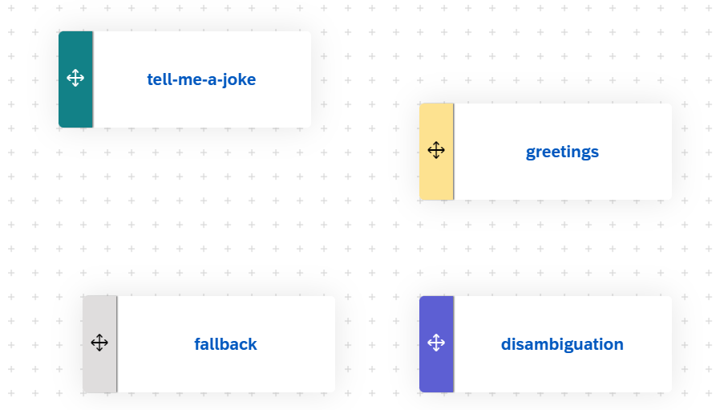

1. Run the chat bot. How does it respond to “hello”? Why?(2)

Because “hello” is in indent greeting.

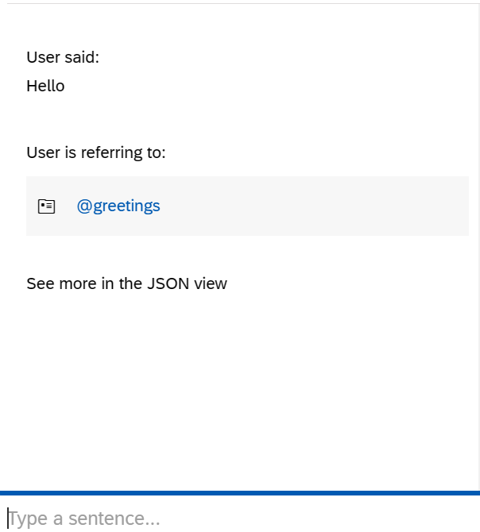

1. How does it respond to “tell a joke”? Why? (2)

Because “tell a joke” trigged the @tell-me-a-joke skill.

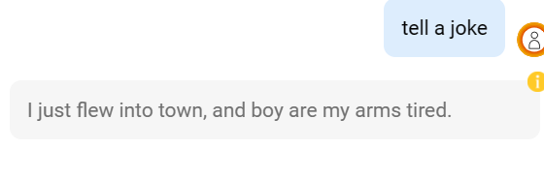

1. How does it respond to “I want a joke”? Why? (2)
2. Because “I want a joke” trigged the @tell-me-a-joke skill.

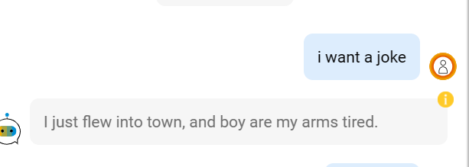

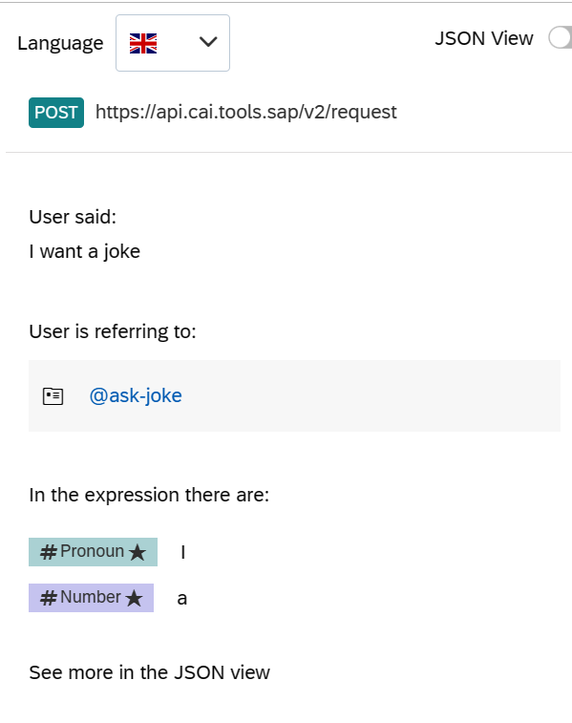

**Problem 2**

<https://developers.sap.com/group.cai-shipping-bot.html>

Three tasks –

* Create Chatbot for Customers for Shipping Company
  + Create a Chatbot that lets customers track packages - <https://developers.sap.com/tutorials/cai-bot-shipping-1-track-bot.html>
  + Add webhook to chatbot to retrieve tracking info - <https://developers.sap.com/tutorials/cai-bot-shipping-2-api.html>
  + Let customers ask chatbot for shipping price - <https://developers.sap.com/tutorials/cai-bot-shipping-3-price-parcel.html>

Insert screenshots to support each answer.

1. Show a chat session to track this package - *1Z04E04A0346619330* (5)

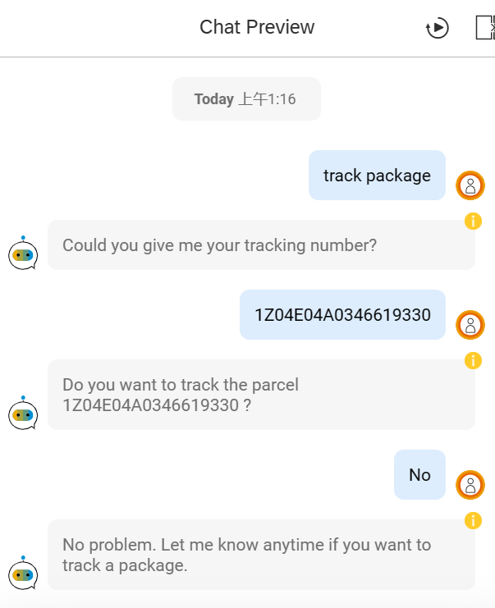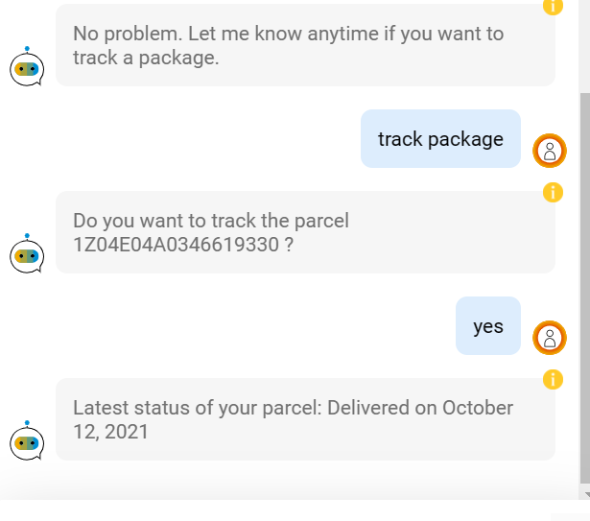

1. Show a chat session to get pricing for shipping large package to *Champ de Mars, 5 Av. Anatole France, 75007 Paris, France* (5)

